**AI**

**Collaborative Study**

Full Scale Collaborative Study

for the

Determination of AI formulations by ….

Report to CIPAC

by

XXX

May 20XX

# Participants

In September 20XX, Information Sheet No. XXX was sent out by the CIPAC Secretary, inviting members to participate in a collaborative study XXXX

The results of all 20 participants were evaluated.

The participating 20 laboratories are listed in alphabetical order, whereas lab numbers in the result tables were assigned randomly.

|  |
| --- |
| Name of institution Street, no. Postal code, city  State |
| ⁝ ⁝ |

# 

# Active Ingredient: General Information

Chemical name: IUPAC x

CAS x

ISO common name: AI

Structure: figure molecule

Molecular formula: XXXXXXXX

Molecular mass: xxx.x g/mol

Activity: xxxxxxxxx

# Samples

Five test samples and one analytical standard were sent to the participants:

1. TC
2. EC
3. SC
4. etc.

Reference standard purity 99.8 % w/w

# Method

* 1. **Scope**

The determination of active ingredient content contained within a technical sample (TC) and …….

* 1. **Principle**

The content of AI (g/kg) is determined by reversed phase high performance liquid chromatography using UV detection at XXX nm and external standard calibration.

* 1. **Procedure**

Each sample was analyzed using four independent determinations

# Remarks of the Participants

Several participants provided comments about the method performance and also made note of deviations from the method:

|  |  |  |
| --- | --- | --- |
| Laboratory 1 | Column: Remarks: | Zorbax Extend C18 (50 x 4.6 mm, 3.5 µm) Filtration instead of centrifugation |
| Laboratory 2 | Oven temperatures:  Detector: Remarks: | 40 °C FID None |
| Laboratory 3 | Carrier gas:  Flow rate: Remarks: | Hydrogen 1 ml/min None |
| …………….. |  |  |

# Evaluation and Discussion

* 1. **Data Review**

The data obtained from each laboratory was visually reviewed to determine if there were any significant chromatography differences, from what was expected, which might affect the analytical results.

In summary it can be stated that the method deviations, noted by the participating …….

* 1. **Determination of AI**

The statistical evaluation of the data was accomplished following the new CIPAC Guideline, according to DIN ISO 5725.

The testing for outliers / stragglers of the laboratory mean values were performed according to Grubbs test on a 1 % / 5 % significance level, respectively.

All results reported by the XX laboratories are reported and the statistical evaluation of these are listed in Tables 1-2 and displayed in Figures 1-5. These results are reported without any exclusion of outliers and/or stragglers.

In addition, a separate evaluation, listed in Table 3-4 and Figures 6-10, display the results with the exclusion of outliers.

**Determination of AI – Full set of 20 participants**

**Table 1 - Results** (content in g/kg)

|  |  |  |  |  |  |  |  |  |  |  |  |
| --- | --- | --- | --- | --- | --- | --- | --- | --- | --- | --- | --- |
| **Laboratory** | **Day** | **TC** |  | **EC** |  | **SC I** |  | **SC II** |  | **FS** |  |
| 1 | 1 | 991 | 991.00 | 253.2 | 252.80 | 86.0 | 86.00 | 405 | 404.00 | 7.21 | 7.415 |
| 2 | 991 | 252.4 | 86.0 | 403 | 7.62 |
| 2 | 1 | 989 | 990.50 | 248.8 | 249.75 | 83.4 | 83.65 | 395 | 397.00 | 6.95 | 6.960 |
| 2 | 992 | 250.7 | 83.9 | 399 | 6.97 |
| 3 | 1 | 991 | 987.50 | 251.6 | 251.40 | 86.2 | 85.70 | 407 | 407.50 | 7.32 | 7.225 |
| 2 | 984 | 251.2 | 85.2 | 408 | 7.13 |
| 4 | 1 | 988 | 989.50 | 253.0 | 253.50 | 85.9 | 85.65 | 403 | 403.50 | 7.06 | 7.070 |
| 2 | 991 | 254.0 | 85.4 | 404 | 7.08 |
| 5 | 1 | 996 | 988.50 | 246.5 | 248.95 | 83.2 | 82.90 | 402 | 400.50 | 6.81 | 6.795 |
| 2 | 981 | 251.4 | 82.6 | 399 | 6.78 |

**Table 2 – Summary of the statistical evaluation**

|  |  |  |  |  |  |
| --- | --- | --- | --- | --- | --- |
|  | Prothioconazole Tech. | Prothioconazole EC 250 g/L | Prothioconazole SC 100 g/L | Prothioconazole SC 480 g/L | Prothioconazole FS 258 g/L  (8 g/L Prothioconazole) |
| ***xm*** [g/kg] | 988.7 | 252.54 | 86.03 | 410.1 | 7.163 |
| ***xm*** [% w/w] | 98.87 | 25.254 | 8.603 | 41.01 | 0.7163 |
| ***n*** | 20 | 20 | 20 | 20 | 19 |
| ***sr*** | 5.34 | 2.23 | 1.63 | 4.28 | 0.304 |
| ***sR*** | 8.49 | 3.52 | 3.03 | 17.19 | 0.323 |
| **r** | 14.96 | 6.24 | 4.56 | 11.99 | 0.851 |
| **R** | 23.78 | 9.86 | 8.50 | 48.12 | 0.905 |
| **RSDR** [%] | 0.86 | 1.39 | 3.53 | 4.19 | 4.511 |
| **RSDR (Hor)** [%] | 2.00 | 2.46 | 2.89 | 2.29 | 4.21 |
| **HorRat** | 0.43 | 0.56 | 1.22 | 1.83 | 1.07 |

*xm* = overall sample mean

*n* = number of laboratories

*sr* = repeatability standard deviation

*sR* = reproducibility standard deviation

r = repeatability limit

R = reproducibility limit

RSDr = relative repeatability standard deviation [%]

RSDR = relative reproducibility standard deviation [%]

HorRat = RSDR/RSDR (Hor) (Horwitz Ratio)

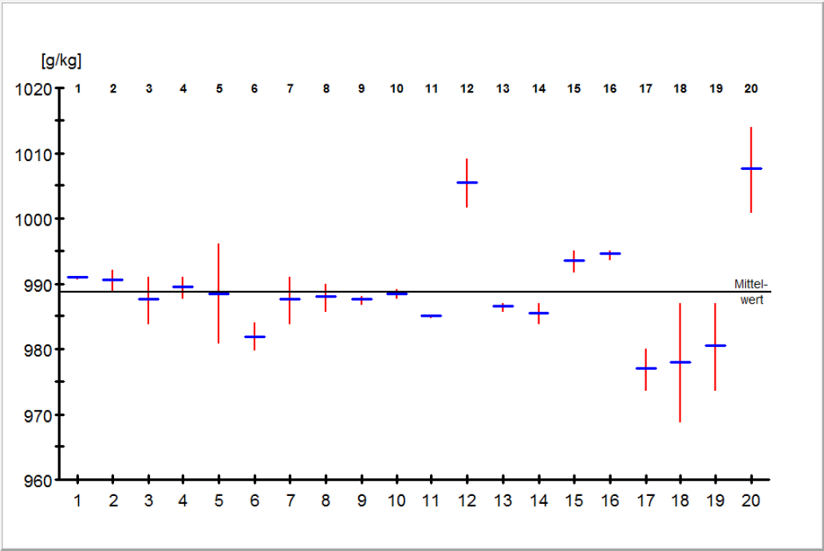**Fig. 1 – AI technical**

|  |  |
| --- | --- |
| Mean value 988.7 g/kg | RSDR  0.86 % |
| *sr*5.34 | RSDR (Hor) 2.00 % |
| *sR*8.49 | HorRat 0.43 |
| Outlier (Grubbs) none |  |

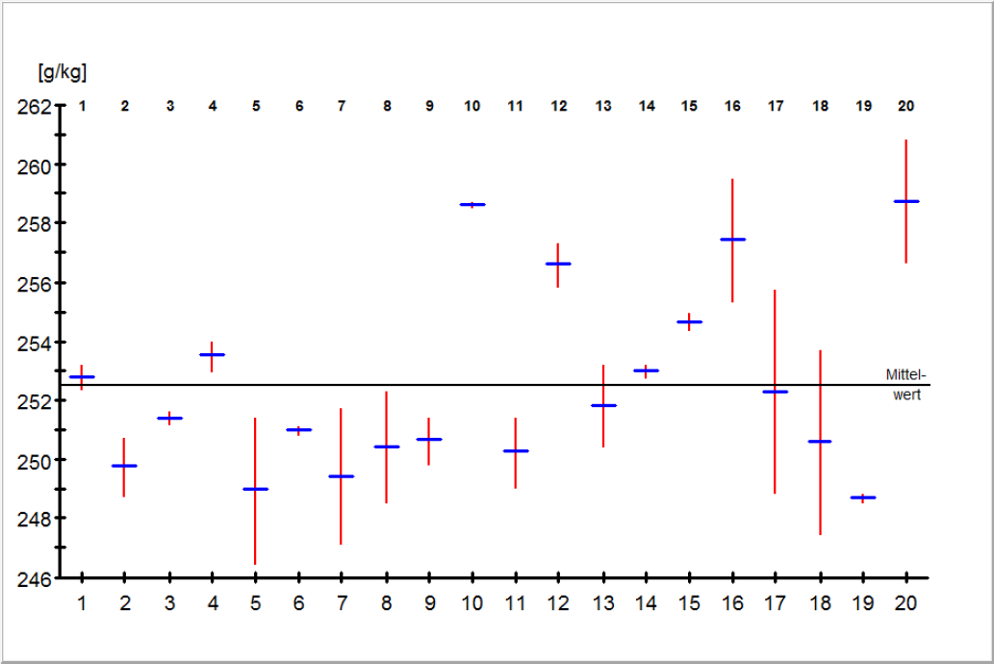**Fig. 2 – AI EC**

|  |  |
| --- | --- |
| Mean value 252.54 g/kg | RSDR  1.39 % |
| *sr*2.23 | RSDR (Hor) 2.46 % |
| *sR*3.52 | HorRat 0.56 |
| Outlier (Grubbs) none |  |

**Determination of AI – Elimination of outliers**

**Table 3 – Summary of the statistical evaluation (without outliers)**

|  |  |  |  |  |  |
| --- | --- | --- | --- | --- | --- |
|  | Prothioconazole Tech. | Prothioconazole EC 250 g/L | Prothioconazole SC 100 g/L | Prothioconazole SC 480 g/L | Prothioconazole FS 258 g/L |
| ***xm*** [g/kg] | 988.7 | 252.54 | 85.49 | 406.6 | 7.123 |
| ***xm*** [% w/w] | 98.87 | 25.254 | 8.549 | 40.66 | 0.7123 |
| ***n*** | 20 | 20 | 19 | 19 | 18 |
| ***sr*** | 5.34 | 2.23 | 1.63 | 4.10 | 0.127 |
| ***sR*** | 8.49 | 3.52 | 1.83 | 7.00 | 0.196 |
| **r** | 14.96 | 6.24 | 4.55 | 11.4 | 0.356 |
| **R** | 23.78 | 9.86 | 5.13 | 19.5 | 0.548 |
| **RSDR** [%] | 0.86 | 1.39 | 2.14 | 1.72 | 2.75 |
| **RSDR (Hor)** [%] | 2.00 | 2.46 | 2.90 | 2.29 | 4.21 |
| **HorRat** | 0.43 | 0.56 | 0.73 | 0.75 | 0.65 |

*xm* = overall sample mean

*n* = number of laboratories

*sr* = repeatability standard deviation

*sR* = reproducibility standard deviation

r = repeatability limit

R = reproducibility limit

RSDr = relative repeatability standard deviation [%]

RSDR = relative reproducibility standard deviation [%]

HorRat = RSDR/RSDR (Hor) (Horwitz Ratio)

# Conclusions

In total, 22 laboratories from Asia, America and Europe participated in the trial, 20 laboratories came back in time and provided results. The data sets from all these laboratories have been considered for the statistical evaluating (Figures x to x and Tables x to x). For sample A, the results of two laboratories have been eliminated as outlier results. In a second attempt (Table x), only laboratories using the method as given (column and carrier gas) were considered. For this subgroup the HorRat was lower than in the overall group even without any outlier elimination. … The final set of 14 laboratories is given in Table x.

The data presented in the statistical summary show that the method is suitable to obtain acceptable and reproducible results for all samples tested and is therefore regarded to be robust.

The requirement of the CIPAC guideline that accepted results were provided by not less than 8 laboratories coming from at least 5 countries of 2 continents is fulfilled.

.

*Company* considers this method to be suitable for the intended purpose, without further changes, and recommends accepting it as a **provisional CIPAC** **method** for the determination of AI in technical material and associated formulations: XX …..