CIPAC

COLLABORATIVE INTERNATIONAL PESTICIDES ANALYTICAL COUNCIL LIMITED

Commission Internationale des Méthodes d'Analyse des Pesticides (CIMAP)

CIPAC Prepublished Methods:
Adopted CIPAC methods are available on a per-method basis as pdf-file, as long as they are not yet published in a Handbook. CIPAC charges a nominal fee per method. The list on the order form is exhaustive, which means that methods which are not on the list are not available. The list of methods (see http://www.cipac.org/prepubme.htm) covers the time period of adoption of methods at the from going to press of Handbook O (summer 2012) to present (September 2014, after CIPAC Meeting in Liège, Belgium). For further details see prepublished order form.

Terms of Use:
By ordering one or more of these methods, the user accepts the conditions of use as follows:
- these are draft methods and are subject to revision without further notice
- these methods will appear in revised and edited form in CIPAC Handbook O presumably in the year 2015. The prepublished methods expire as soon as they appear in printed form in the CIPAC Handbook O.
- The CIPAC copyright and disclaimer (cf. CIPAC Handbook N, page ii) applies to all prepublished methods.

PYRAOXYSTROBIN
964

ISO common name Pyraoxystrobin

Chemical name methyl (2E)-2-(2-{[3-(4-chlorophenyl)-1-methylpyrazol-5-yl]oxymethyl} phenyl)-3-methoxyacrylate (IUPAC)
methyl (αE)-2-[[[3-(4-chlorophenyl)-1-methyl-1H-pyrazol-5-yl]oxy]methyl] -α-(methoxymethylene)benzeneacetate (CA; 862588-11-2)

Empirical formula C₂₂H₂₁ClN₂O₄

RMM 412.87

m.p. 129.6°C

v.p. 1.22×10⁻⁸ Pa at 20°C

Solubility In water 0.03 mg/L at 20°C; high solubility in N,N-Dimethylformamide, acetone, ethyl acetate, toluene, acetonitrile

Stability Not stable in alcohol to heat

Description The pure material is a white, odourless solid

Formulation Suspension concentrates (SC)

PYRAOXYSTROBIN technical
964/TC/M/-

1 Sampling. Take at least 100 g.

2. Identity test

2.1 HPLC. Use the reversed phase HPLC method below. The relative retention time of the Pyraoxystrobin peak in the sample solution should not deviate by more than 1.5% from that of the calibration solution.

2.2 Infrared. Prepare potassium bromide discs for the technical sample and pyraoxystrobin reference substance. A typical potassium bromide disc should contain a sample prepared in the 0.15-0.35% by weight range. Scan the discs from 4000 to 600 cm⁻¹. The spectrum from the sample should not differ significantly from that of the reference substance.

3 Pyraoxystrobin

OUTLINE OF METHOD Pyraoxystrobin is determined by reversed phase high performance liquid chromatography using UV detection at 280 nm and external standardisation.

REAGENTS

Acetonitrile HPLC grade
Water HPLC grade

Pyraoxystrobin reference standard of known content. Store refrigerated.

Calibration solutions. Weigh in duplicate about 40 mg (to the nearest 0.1 mg) of pyraoxystrobin reference standard (s mg) into separate volumetric flasks (100 ml). Add acetonitrile (about 80 ml) and place the flask in an ultrasonic bath for 15 min. Allow to cool to ambient temperature and fill to the mark with acetonitrile. Mix thoroughly. (calibration solutions C_{A} and C_{B}).

APPARATUS

High performance liquid chromatograph equipped with a detector suitable for operation at 280 nm (UV-detection) and an injection system capable of injecting 5 µl.

Liquid chromatographic column stainless steel, 150 x 4.6 mm (i.d.), Agilent ZORBAX SB C₁₈, 5 µm, or equivalent with the same selectivity.

Electronic integrator or data system

Ultrasonic bath

PROCEDURE

- Chromatographic conditions (typical)

Column temperature 30°C
Flow rate 1.3 ml/min
Detector wavelength 280 nm
Injection volume 5 µl
Mobile phase acetonitrile - water, 600 + 400 (v/v)
Retention time pyraoxystrobin approximately 6.4 min

- Equilibration of the system. Pump sufficient mobile phase through the column to equilibrate the system. Inject 5 µl portion of calibration solution C_{A} until the response obtained from two consecutive injections deviate by less than 1.0%. Then inject 5 µl portion of calibration solution C_{B}. The response factor for this solution should not deviate by more than 1.0% from that for calibration solution C_{A}, otherwise prepare new calibration solutions.

- Preparation of sample. Prepare sample solutions in duplicate for each sample. Weigh (to the nearest 0.1 mg) sufficient sample (w mg) to contain about 40 mg of pyraoxystrobin (s mg) into a volumetric flask (100 ml). Add acetonitrile (about 80 ml) and place the flask in an ultrasonic bath for 15 min. Allow to cool to ambient temperature and fill to the mark with acetonitrile. Mix thoroughly. (sample solutions S₁ and S₂).

- Determination. Inject in duplicate 5 μl portions of each sample solution bracketing them by injections of the calibration solutions as follows: calibration solution C_{A}, sample solution S₁, sample solution S₁, calibration solution C_{B}, sample solution S₂, sample solution S₂, calibration solution C_{A}, and so on. Measure the relevant peak areas. Average the values of the duplicate sample injections. Calculate the mean values of the response factors of the calibration solution bracketing two sample solutions and use this value to calculate the pyraoxystrobin content of the bracketed samples.

- Calculation. Determine the peak area of pyraoxystrobin and calculate the mean value of response factors from the calibration solutions bracketing the injections of the sample solutions and use this value for calculating the pyraoxystrobin content of the bracketed sample solutions. The pyraoxystrobin content is the mean value of two sample solutions.

Pyraoxystrobin content g/kg
where:
f_{i} = individual response factor
f = mean response factor
H_{s} = peak area of pyraoxystrobin in the calibration solution
H_{w} = peak area of pyraoxystrobin in the sample solution
s = mass of pyraoxystrobin reference standard in the calibration solution (mg)
w = mass of sample taken (mg)
P = purity of pyraoxystrobin reference standard (g/kg)

PYRAOXYSTROBIN suspension concentrates

964/SC/M/-

1 Sampling. Take at least 600 ml.

2. Identity test

2.1 HPLC. As for pyraoxystrobin technical 964/TC/M/2.1

2.2 HPLC-MS

PROCEDURE

- Preparation of sample. Homogenise the sample by vigorous shaking Weigh (to the nearest 0.1 mg) sufficient sample to contain about 20 mg of pyraoxystrobin into a volumetric flask (50 ml). Add acetonitrile (about 40 ml) and place the flask in an ultrasonic bath for 15 min. Allow to cool to ambient temperature and fill to the mark with acetonitrile. Mix thoroughly. Filter through a 0.45 µm PTFE filter prior to injection.

- Chromatographic conditions (typical)

Liquid chromatographic column stainless steel, 150 x 4.6 mm (i.d.), Agilent ZORBAX Extend C₁₈, 5 µm, or equivalent with the same selectivity.
Column temperature 30°C
Flow rate 1.0 ml/min
Injection volume 10 µl
Mobile phase acetonitrile - water, 500 + 500 (v/v)
Detector MS
Ionisation mode +ESI
Full scan mode 100 - 1000 m/z
Total run time 25 min
Retention time pyraoxystrobin approximately 15 min

The spectrum produced from the sample should not differ significantly from that of the standard.

3 Pyraoxystrobin

As for pyraoxystrobin technical 964/TC/M/3 except

- Preparation of sample. Homogenise the sample by vigorous shaking. Prepare sample solutions in duplicate for each sample. Weigh (to the nearest 0.1 mg) sufficient sample (w mg) to contain about 40 mg of pyraoxystrobin (s mg) into a volumetric flask (100 ml). Add acetonitrile (about 80 ml) and place the flask in an ultrasonic bath for 15 min. Allow to cool to ambient temperature and fill to the mark with acetonitrile. Mix thoroughly. Filter an aliquot of each prepared solution through a 0.45 µm PTFE filter prior to analysis (sample solutions S₁ and S₂).

4 Suspensibility

REAGENTS AND APPARATUS. As for pyraoxystrobin technical 964/TC/M/- and MT 184.

PROCEDURE

- Preparation of suspension and determination of sedimentation. MT184.

- Determination of pyraoxystrobin in the bottom 25 ml of suspension. After removal of the top 225 ml of suspension transfer the remaining 25 ml to a volumetric flask (100 ml) with acetonitrile (50 ml). Place the flask in an ultrasonic bath for 15 min. Allow to cool to ambient temperature and fill to the mark with acetonitrile. Mix thoroughly. Filter through a 0.45 µm filter prior to analysis. Determine the mass of pyraoxystrobin (Q g) by 964/TC/M/3.

- Calculation

Suspensibility%
where:
c = mass of pyraoxystrobin in the sample taken for the preparation of the suspension (g)
Q = mass of pyraoxystrobin in the bottom 25 ml of suspension (g)

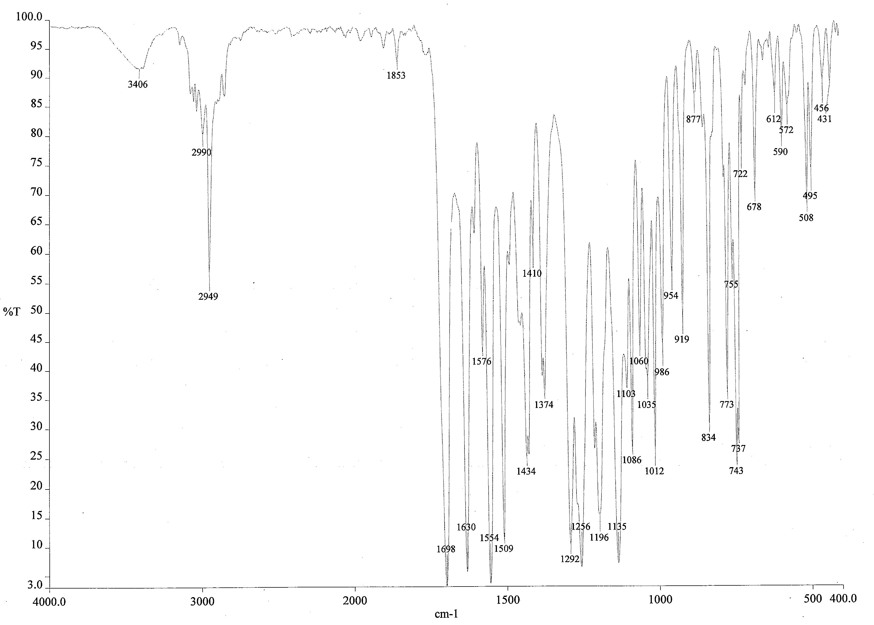

Fig.1 Infrared spectrum of pyraoxystrobin

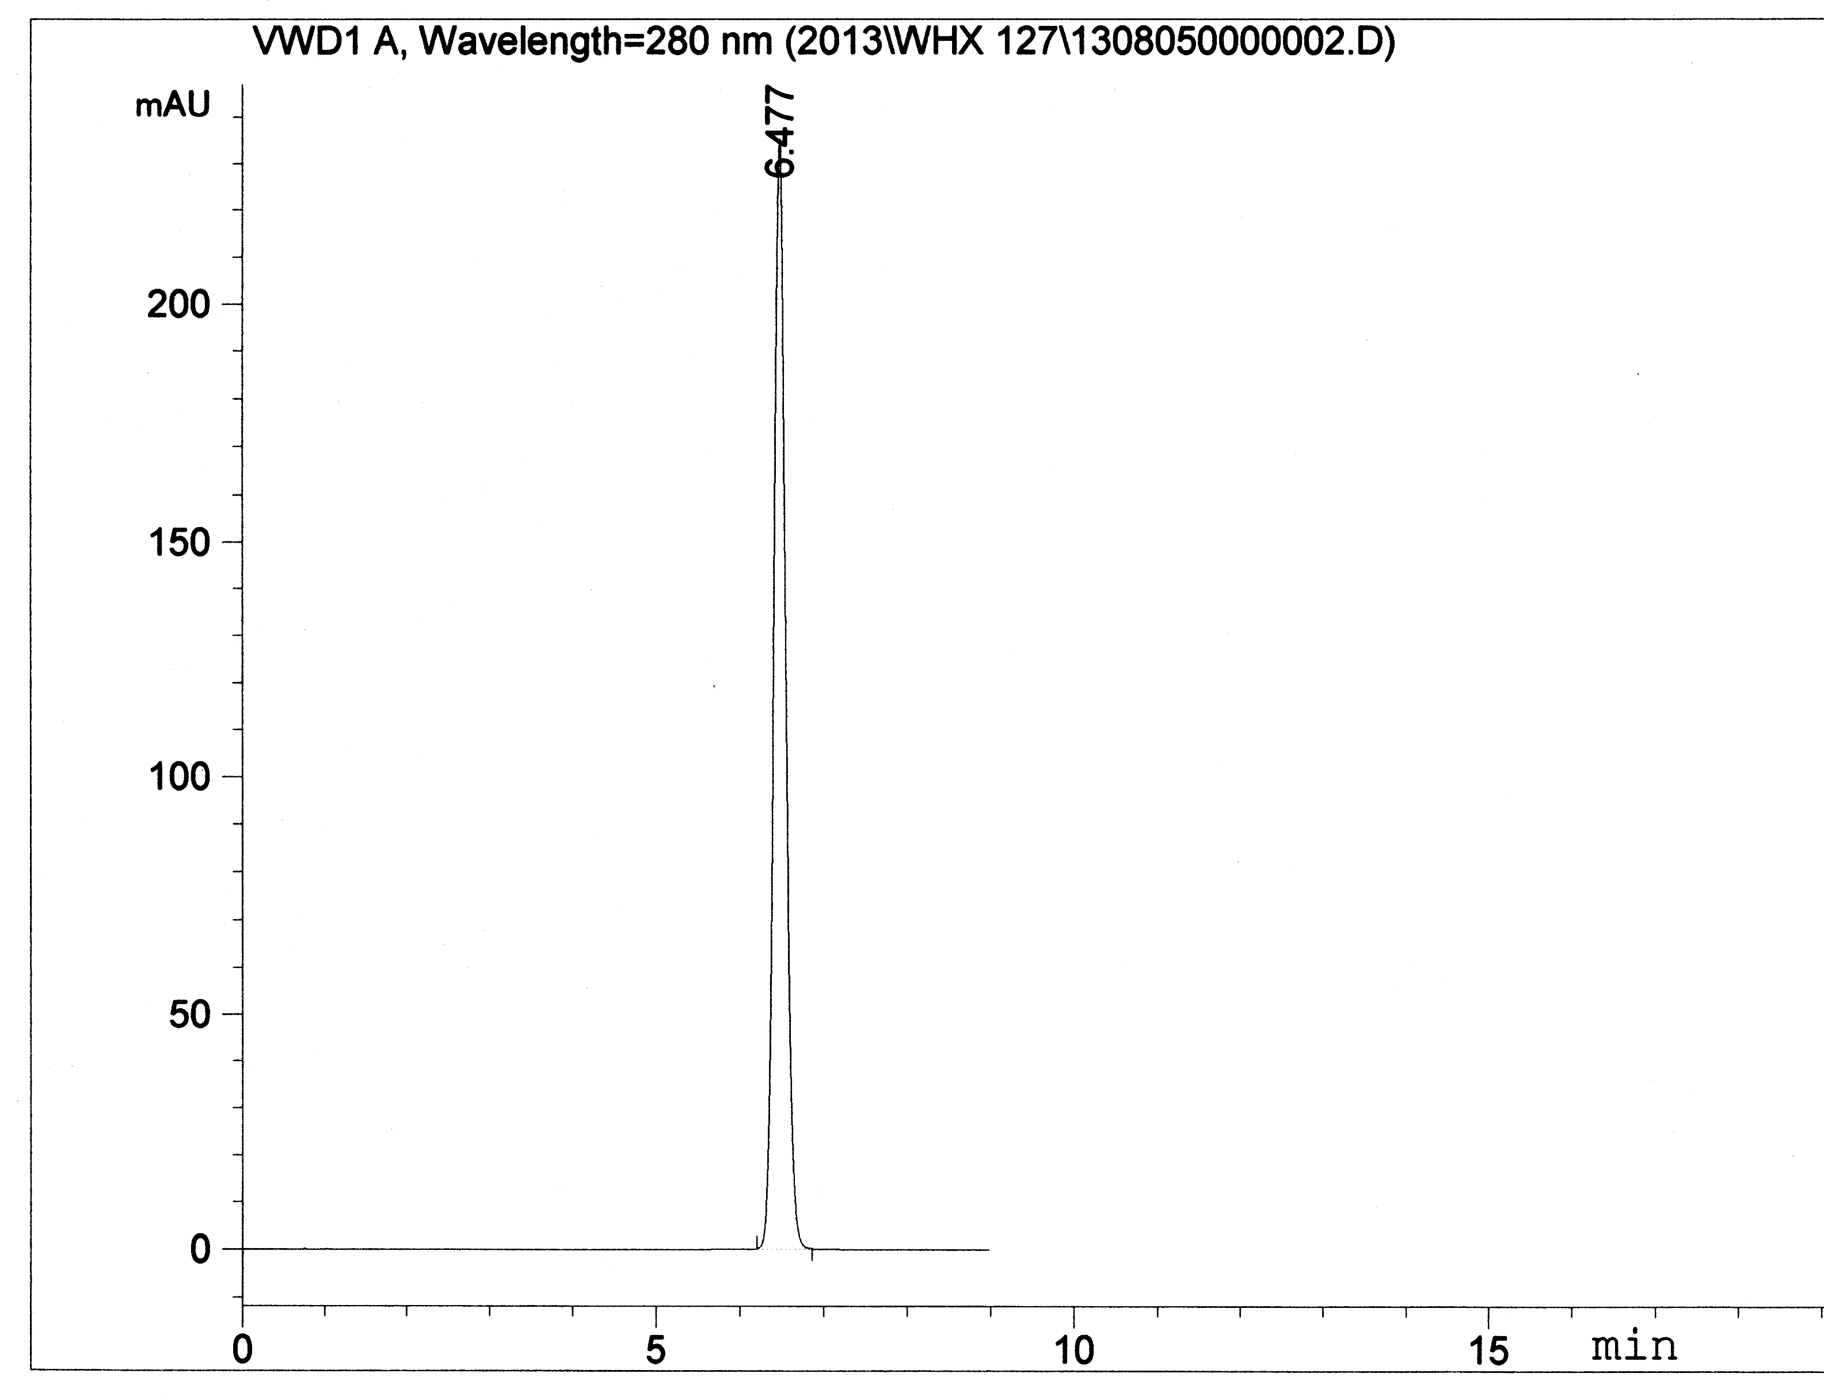
Fig.2 HPLC chromatogram of pyraoxystrobin standard

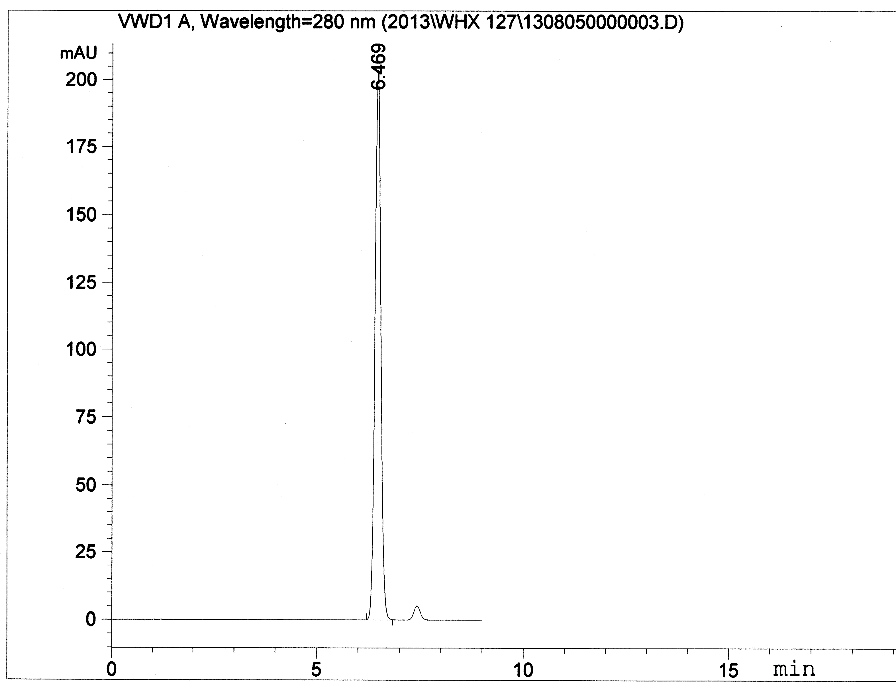
Fig.3 HPLC chromatogram of pyraoxystrobin TC

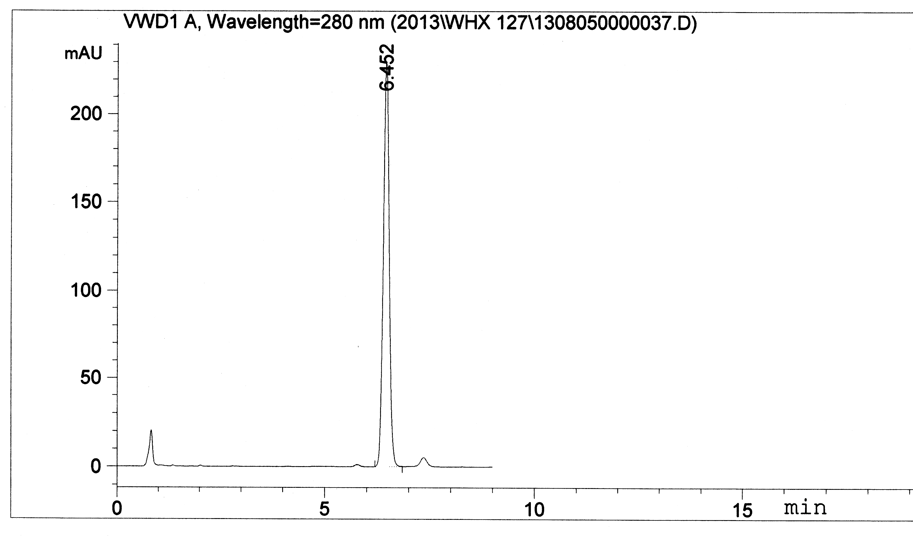
Fig.4 HPLC chromatogram of pyraoxystrobin SC

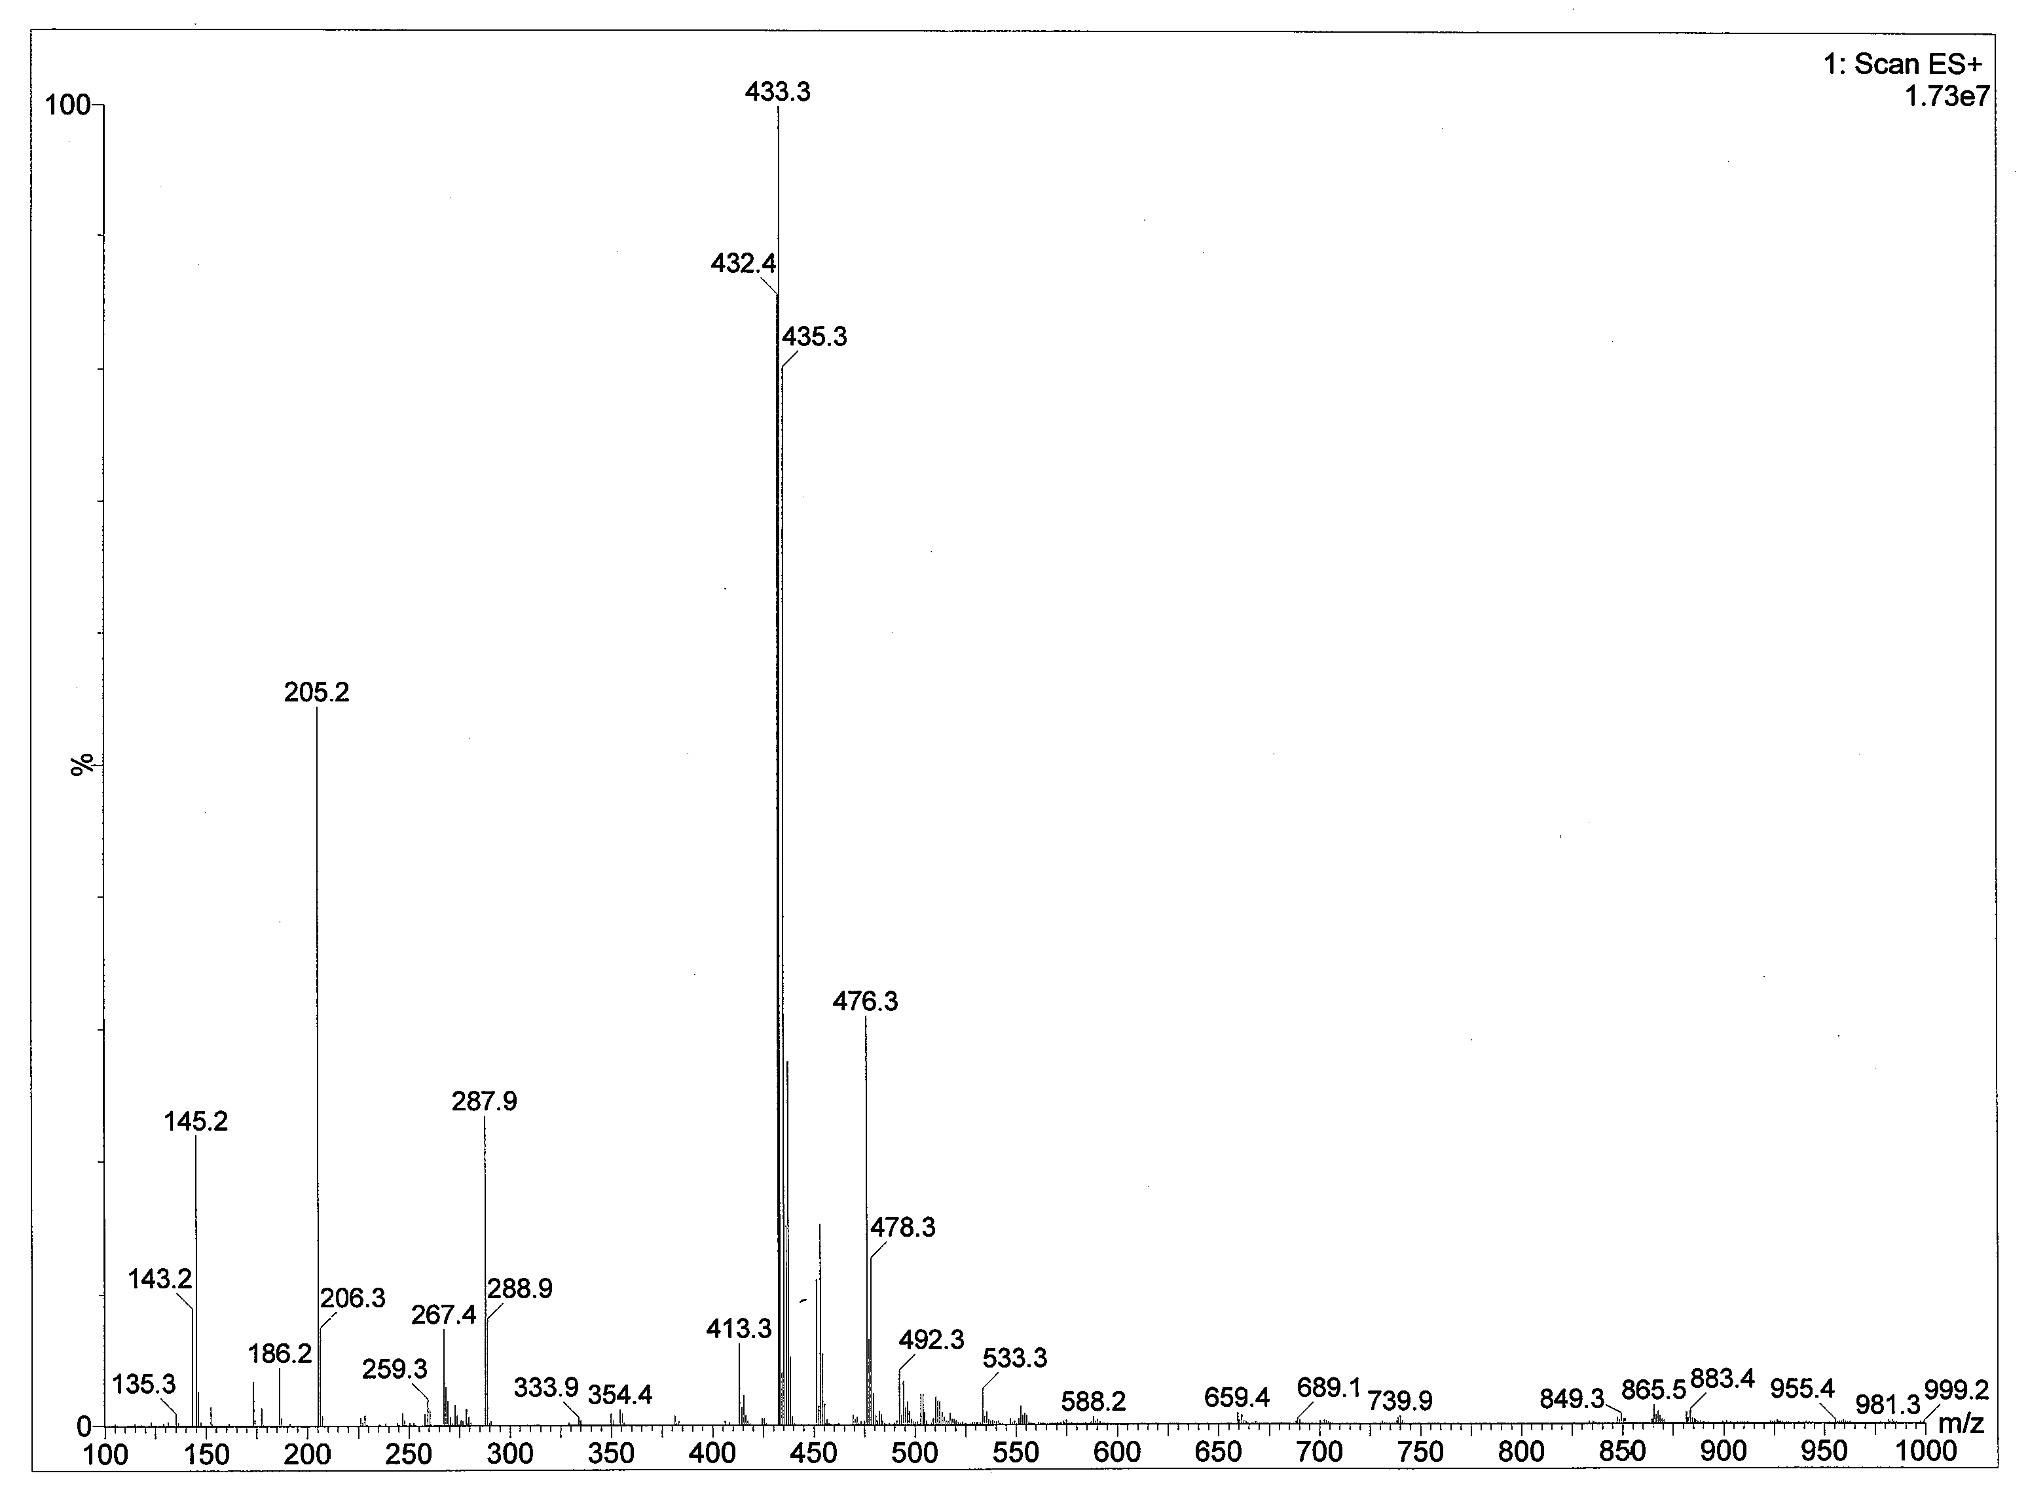
Fig.5 HPLC-MS spectrum of pyraoxystrobin standard

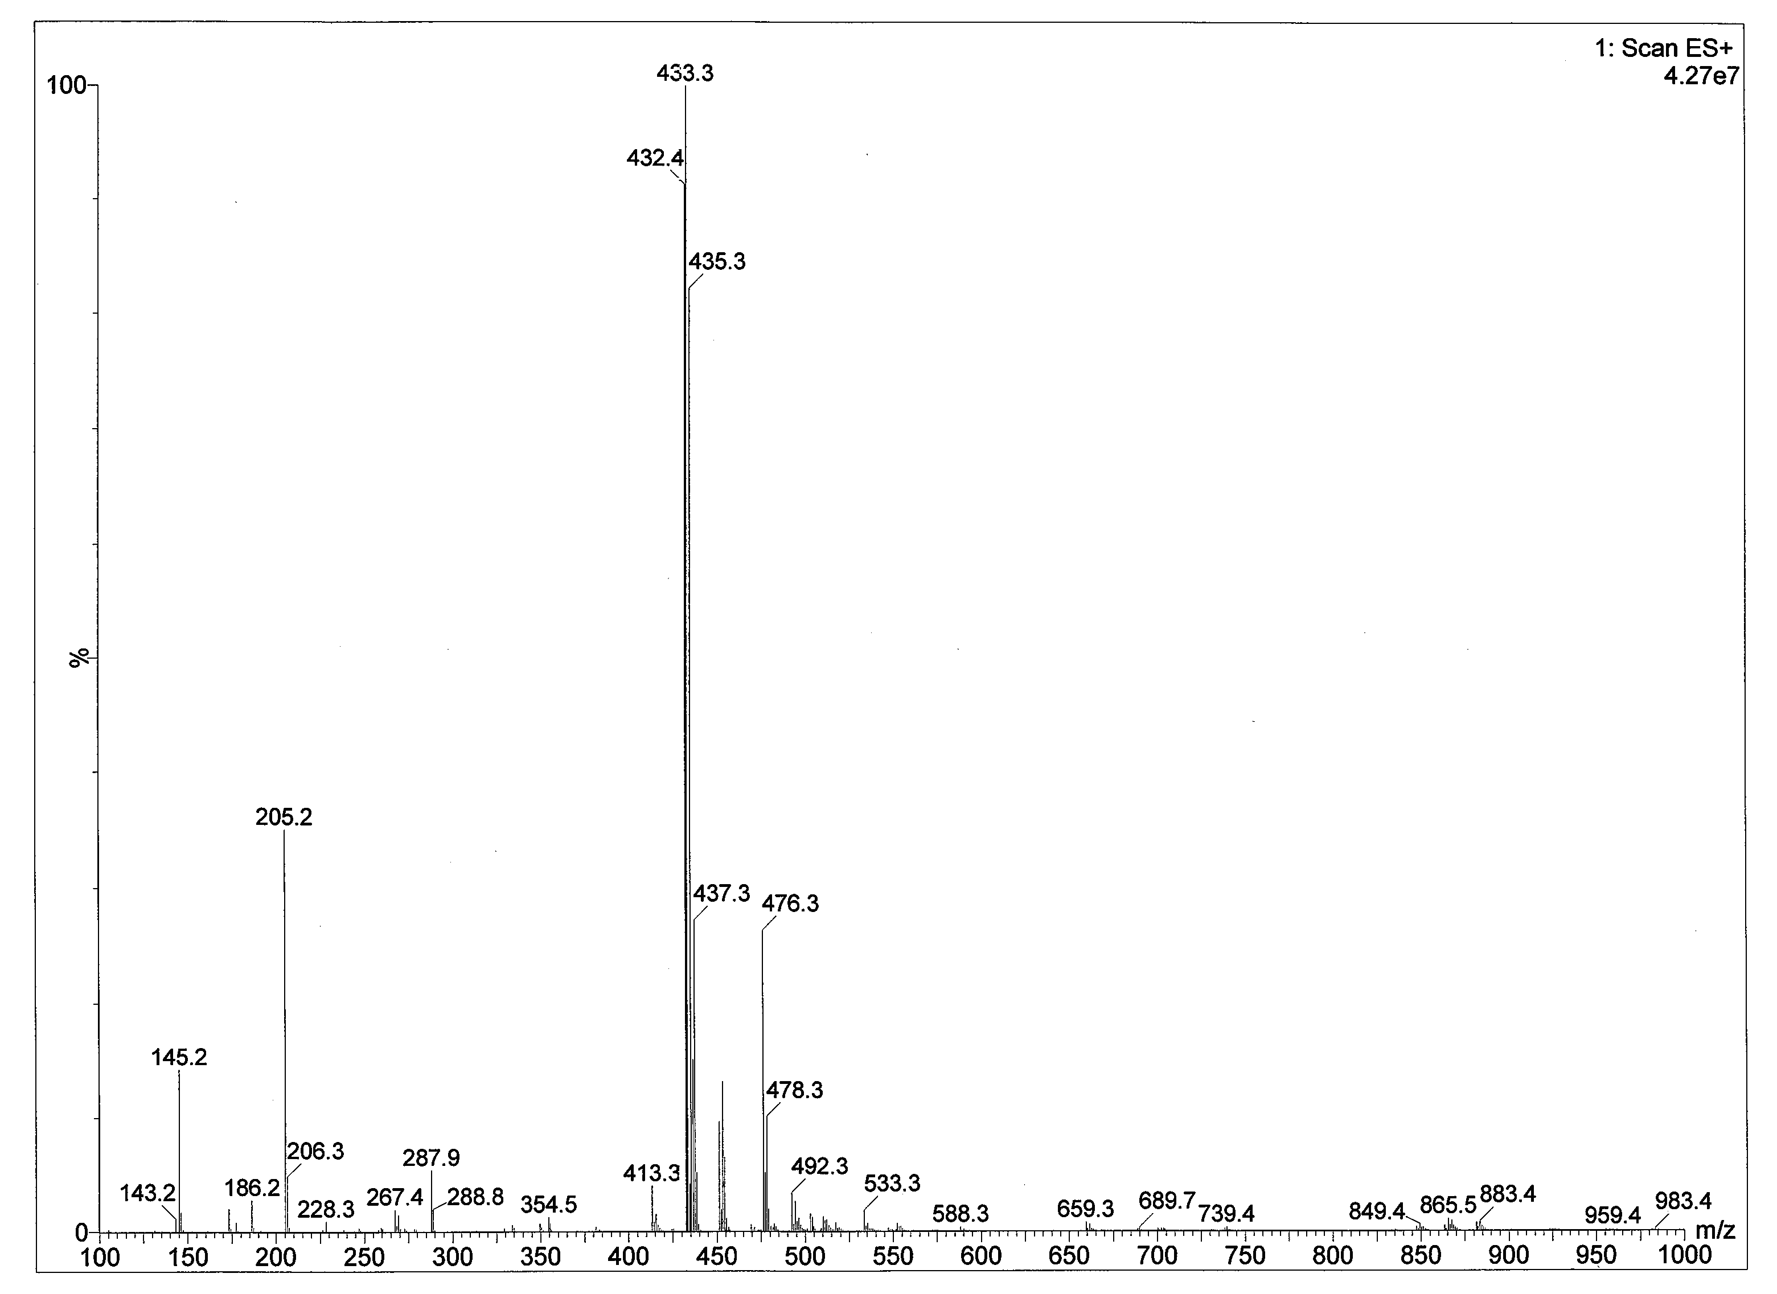
Fig.6 HPLC-MS spectrum of pyraoxystrobin SC

