**CIPAC**

COLLABORATIVE INTERNATIONAL PESTICIDES ANALYTICAL COUNCIL LIMITED

Commission Internationale des Méthodes d'Analyse des Pesticides (CIMAP)

**CIPAC Prepublished Methods:**

Adopted CIPAC methods are available on a per-method basis as pdf-file, as long as they are not yet published in a Handbook. CIPAC charges a nominal fee per method. The list on the order form is exhaustive, which means that methods, which are not on the list, are not available. The list of methods (see <http://www.cipac.org/prepubme.htm>) covers the time period of adoption of methods at the from going to press of Handbook O (summer 2012) to present (September 2014, after CIPAC Meeting in Liège, Belgium). For further details, see prepublished order form.

**Terms of Use:**

By ordering one or more of these methods, the user accepts the conditions of use as follows:

* these are draft methods and are subject to revision without further notice
* these methods will appear in revised and edited form in CIPAC Handbook O presumably in the year 2015. The prepublished methods expire as soon as they appear in printed form in the CIPAC Handbook O.
* The CIPAC copyright and disclaimer (cf. CIPAC Handbook N, page ii) applies to all prepublished methods.

**PIRIMIPHOS-METHYL**

**239**



*ISO Common Name* Pirimiphos-methyl

*Chemical Name* *O*-2-Diethylamino-6-methylpyrimidin-4-yl   
*O, O*-dimethyl phosphorothioate(IUPAC);

methyl 2-[[[[[4,6-bis(difluoromethoxy)-2-pyrimidinyl]-mino]carbonyl]amino]sulfonyl]benzoate *(*CA*; 29232-93-7*)

*Empirical formula* C11H20N3O3PS

*RMM.* 305.3

*b.p.* decomposes on distillation

*m.p.* 5-18 ºC

*v.p.* 2.3 × 10-6 Pa at 20 °C

*Solubility* In water 10 mg/l, 20 °C (pH 7); miscible with most organic solvents, e.g. alcohols, ketones, halogenated hydrocarbons

*Description* Straw-coloured liquid

*Stability* Hydrolysed by concentrated acids and alkalis

*Formulations* Emulsifiable concentrates and capsule suspensions

**PIRIMIPHOS-METHYL TECHNICAL**

**[1]*239**/TC/M/-

**1 Sampling.** Take at least 100 g.

**2 Identity tests**

**2.1 Infrared.** Prepare a film between sodium chloride plates and scan from 4000 to 650 cm-1. The spectrum obtained from the sample should not differ significantly from that of the standard.

**2.2 GLC**. Use the capillary GC method below. The retention time of pirimiphos-methyl for the sample solution should not deviate by more than 2% from that of the calibration solution.

**3 Pirimiphos-methyl**

OUTLINE OF METHOD The sample of pirimiphos-methyl technical material is dissolved in acetone, containing an internal standard, and the pirimiphos-methyl content determined by capillary gas chromatography.

REAGENTS

*Pirimiphos-methyl* standard of known purity. Even purified standard of pirimiphos-methyl is not very stable at room temperature. It is important to keep the standard in a refrigerator. Before taking out standard from the bottle, it must be ensured that the temperature of the bottle has reached room temperature. Depending on the amount in the bottle this may take up to 4 hours. Accelerating this process by putting the bottle into a water bath with a temperature above 25°C is not recommended because this can cause degradation of the active substance.

*Acetone*

*4,4'-*Dimethoxybenzophenone internal standard. Must not contain impurities with the same retention time as pirimiphos-methyl.

*Internal standard solution*. Dissolve 0.20 g of 4,4'-dimethoxybenzophenone in acetone (100 ml). Prepare sufficient solution for the calibration solutions and the all samples to be analysed.

*Calibration solution.* Prepare calibration solutions in duplicate. Warm the material at 25  C, prior to weighing, to ensure it is completely liquid. Weigh (to the nearest 0.1 mg) 45 - 55 mg (*s* mg) of standard pirimiphos-methyl into a suitable flask or bottle (30 ml). Add by pipette or calibrated dispenser internal standard solution (10.0 ml). Cap the container and place it in an ultrasonic bath for 5 min to ensure complete solution (solutions CA and CB).

APPARATUS

*Gas chromatograph* equipped with split/splitless injection and a flame ionisation detector

*Capillary column* fused silica, 15 m × 0.25 (i.d.) mm coated with crosslinked dimethyl polysiloxane (DB-1 or equivalent); film thickness: 0.25 μm

*Ultrasonic bath* capable of producing 17 W/l. If a bath of lower power is used, the potential consequence is that extraction of the active ingredient in CS formulations could be incomplete and the result obtained could be significantly less than the actual content.

*Electronic integrator* or *data system.*

PROCEDURE

*(a)Gas chromatographic conditions* (typical):

*Column* Fused silica, 15 m × 0.25 mm (i. d.) coated with crosslinked dimethyl polysiloxane (DB-1 or equivalent); film thickness: 0.25 μm

*Injection system*

Injector split injection

Injection volume 1 μl

Split ratio 100:1

*Detector* flame ionisation

*Temperatures*

Injection port 170 ºC (Depending on the equipment used, an injection port temperature higher than 170°C may be used, but it has to be carefully considered and checked to avoid any degradation of pirimiphos-methyl in the injection system.)

Detector 310 ºC

Oven programme temp 1: 60 ºC, hold 0 min, ramp rate 25 ºC/min

temp 2: 100 ºC, hold 0 min, ramp rate 40 ºC/min

temp 3: 280 ºC, hold 1 min

*Gas flow rates*

Helium (carrier) 2 ml/min (typically 86 kPa at 60 °C); run at constant flow

Air 400 ml/min

Hydrogen 30 ml/min

Nitrogen (make up) to 30 ml/min

*Retention times* pirimiphos-methyl: about 4.8 min

internal standard: about 5.4 min

*(b) System equilibration.* Prepare two calibration solutions. Inject 1 μl portions of solution CA until the response factors (*fi*) obtained for two consecutive injections differ by less than 1.0%. Then inject a 1 μl portion of solution CB. The response factor, *fi*, for this solution should not deviate by more than 1.0% from that of solution CA, otherwise prepare new calibration solutions.If the peak retention times differ significantly from the values given, then adjust the flow rate accordingly.

*(c) Sample preparation.* Prepare solutions in duplicate for each sample. Weigh (to the nearest 0.1 mg) sufficient sample to contain 45-55 mg (*w* mg) of pirimiphos-methyl into a suitable flask or bottle (30 ml). Add by pipette or calibrated dispenser the internal standard solution (10.0 ml). Cap the container and place it in an ultrasonic bath for 5 min (solutions SA and SB).

*(d) Determination.* Inject in duplicate 1 μl portions of each sample solution bracketing them with duplicate injections of the calibration solution as follows: calibration solution CA, calibration solution CB, calibration solution CA, sample solution S1A, sample solution S1B, calibration solution CA, sample solution S2A, sample solution S2B, calibration solution CA, and so on for further samples. Measure the relevant peak areas. . If the peak shapes and precision of the analysis deteriorate, due to e.g. build-up of formulation residue in the GC, replace injection liners, gold seals and/or split vent lines

*(e) Calculation.* Calculate the mean value of each pair of response factors bracketing the two injections of a sample (*f*) and use this value for calculating the pirimiphos-methyl contents of the bracketed sample injections.

  
Content of pirimiphos-methyl  g/kg

where:

*fi* = individual response factor

*f* = mean response factor

*Hs* = peak area of pirimiphos-methyl in the calibration solution

*Hw* = peak area of pirimiphos-methyl in the sample solution

*Ir* = peak area of the internal standard in the calibration solution

*Iq* = peak area of the internal standard in the sample solution

*s* = mass of the pirimiphos-methyl reference standard in the calibration  
 solution (mg)

*w* = mass of sample taken (mg)

*P* = purity of pirimiphos-methyl reference standard (g/kg)

**Repeatability r** = 8.6 to14 g/kg at 906 to 958 g/kg active ingredient content

**Reproducibility R** = 15 to 21 g/kg at 906 to 958 g/kg active ingredient  
content

**PIRIMIPHOS-METHYL EMULSIFIABLE CONCENTRATES**

**[2]*239/**EC/M/-

**1 Sampling.** Take at least 100g.

**2 Identity tests**

**2.1 Infrared.** As for technical **239**/TC/M/2.2

**2.2 GLC**. As for technical **239**/TC/M/2.2 and Fig 2.

**3 Pirimiphos-methyl.** As for pirimiphos-methyl technical **239**/TC/M)/3.

**Repeatability r** = 7.2 g/kg at 490 g/kg active ingredient content

**Reproducibility R** = 16 g/kg at 490 g/kg active ingredient content

**PIRIMIPHOS-METHYL CAPSULE SUSPENSIONS**

**\*239/**CS/M/-

**1 Sampling.** Take at least 100g.

**2 Identity tests**

**2.1 Infrared.** Extract a suitable portion of the sample with ethanol. Filter to remove any residue. Evaporate the solvent with a gentle stream of clean and dry air and proceed as for pirimiphos-methyl technical **239**/TC/M/2.2

**2.2 GLC**.As for technical **239**/TC/M/2.2 and Fig xx.

**3 Pirimiphos-methyl.** As for pirimiphos-methyl technical **239**/TC/M/3 except add at:

APPARATUS

*Sample filtering device* with a membrane filtration unit compatible with organic solvents and with a 0.45 µm pore diameter

and change '*(c) Sample preparation'* to:

*(c) Sample preparation.* Prepare solutions in duplicate. Thoroughly homogenise the formulation, as received in the original sales pack, by inverting/shaking the bottle for 2 min or by using a mechanical stirrer. Do not decant a smaller sample or remove the test sample without thorough homogenisation. Weigh (to the nearest 0.1 mg) sufficient sample to contain 45-55 mg (*w* mg) of pirimiphos-methyl into a suitable flask or bottle (30 ml). Add 2 ml of water and cap the bottle then swirl well by hand to produce a uniform dispersion. Add by pipette or calibrated dispenser internal standard solution (10.0 ml). Cap the container and place it in an ultrasonic bath for ~~15~~ 60 min. Note that placing large numbers of containers in the same bath simultaneously will reduce extraction efficiency considerably. Therefore no more than three containers should be treated at once. Filter the solutions through a 0.45 µm filter prior to analysis and discarding the first 1 ml (solutions SA and SB).

**Repeatability r** = 9.9 to 12 g/kg at 282 g/kg active ingredient content

**Reproducibility R** = 18 to 19 g/kg at 282 g/kg active ingredient content

**4 Iso*-*pirimiphos-methyl.** As for **239**/~~CS~~ TC/M/3 except:

OUTLINE OF METHOD Iso-pirimiphos-methyl (*O*-2-diethylamino-6-methylpyrimidin-4-yl *O,S*-dimethyl phosphorothioate) is determined along with pirimiphos-methyl, but due to the instability of iso-pirimiphos-methyl its content is calculated using the response factor of pirimiphos-methyl.

and add:

**2.3 GLC-MS**. Use the GC-MS method below (**239**/CS/M/3.5). The following peaks should appear prominently in the electron impact spectrum: 125.0 amu, 180.0 amu, 276.0 amu, 290.0 amu, and 305.0 amu (Fig. xx).

*(a)Gas chromatographic conditions* (typical):

*Retention times* pirimiphos-methyl: about 4.8 min

iso-pirimiphos-methyl: about 5.2 min

internal standard: about 5.4 min

Note: Ensure that any iso-pirimiphos-methyl peak is well separated from the pirimiphos-methyl peak. The retention time ratio of the two peaks should be at least:



where:

*tiso* = retention time of iso-pirimiphos-methyl

*tp* = retention time of pirimiphos-methyl

and, in case of CS formulations, use in '*(c) Sample preparation'* the description provided in 239/CS/M/3, with the exception of the ultrasonic treatment: The time of the capped container in the ultrasonic bath should only be 15 minutes. Keeping the containers in the ultrasonic bath for 60 minutes may lead to substantial isomerisation between pirimiphos-methyl and iso-pirimiphos-methyl. However, this shorter ultrasonic treatment may be insufficient to fully extract the active substance as well as its isomer from the capsules. Therefore the content of both components in the sample solution must be determined using the chromatographic conditions described in CIPAC method 239a/TC/M**/**3. The final results for the iso- pirimiphos-methyl content are quoted relative to the active ingredient content in the same sample solutions.

and add:

*(e) Calculation.* Calculate the mean value of each pair of response factors of the pirimiphos-methyl calibration solutions bracketing the two injections of a sample, and use this value for calculating the iso-pirimiphos-methyl contents of the bracketed sample injections.



Content of iso-pirimiphos-methyl  g/kg

where:

*fi* = individual response factor of *pirimiphos-methyl*

*f* = mean response factor of *pirimiphos-methyl*

*Hs* = peak area of *pirimiphos-methyl* in the calibration solution

*Hw* = peak area of iso**-**pirimiphos-methyl in the sample solution

*Ir* = peak area of the internal standard in the calibration solution

*Iq* = peak area of the internal standard in the sample solution

*s* = mass of the *pirimiphos-methyl* reference standard in the calibration solution (mg)

*w* = mass of sample taken (mg)

*P* = purity of pirimiphos-methyl reference standard (g/kg)

**Repeatability r** = .. g/kg at … g/kg active ingredient content

**Reproducibility R** = .. g/kg at … g/kg active ingredient content

**5 Other relevant impurities**

*O,O*-dimethyl phosphorochloridothioate (DMPCT)

*O,O,O*-trimethyl phosphorothioate (MeOOOPS)

*O,O,S*-trimethyl phosphorothioate (MeOOSPO)

*O,O,S*-trimethyl phosphorodithioate (MeOOSPS)

OUTLINE OF METHOD DMPCT MeOOOPS, MeOOSPO and MeOOSPS are determined relative to the active ingredient by capillary gas chromatography-mass spectrometry with 4,4-dimethoxybenzophenone as internal standard, applying the standard addition mode.

*Note:* The standard addition mode is used because the intensity of the detector signal depends markedly on the presence of other formulation components.

**5.1 Determination of DMPCT, MeOOOPS, MeOOSPO and MeOOSPS**

REAGENTS

*Reference standards*, of known purity, of DMPCT, MeOOOPS, MeOOSPO and MeOOSPS. Even purified standards of these compounds are not very stable at room temperature. It is important to keep them in a refrigerator. Before taking out standard from the bottle, it must be ensured that the temperature of the bottle has reached room temperature. Depending on the amount in the bottle this may take up to 4 hours.

*Acetone* glass distilled grade

*4,4'-Dimethoxybenzophenone* internal standard. Must not contain impurities with the same retention time as the relevant impurities of pirimiphos-methyl

*Internal standard solution*. Dissolve 20 mg of 4,4'-dimethoxybenzophenone in acetone (10.0 ml). Dilute 5.0 ml of this stock solution with acetone to 500.0 ml..

*Reference standard stock solution.* Prepare a single reference standard stock solution. Weigh (to the nearest 0.1 mg) 80 - 90 mg (*s* mg) of each reference standard into the same volumetric flask (100 ml). Add internal standard solution (about 90 ml) and place the flask in an ultrasonic bath for 5 min. Allow to cool and make up to the mark with internal standard solution (reference standard stock solution, solution CA). Transfer by pipette 10.0 ml of solution CA into a volumetric flask (100 ml) and make up to volume with internal standard solution. Mix thoroughly (reference standard working solution, solution CBW).

APPARATUS

*Gas chromatograph* equipped with a split/splitless injection and a mass spectrometer operated in positive electron impact (EI+) mode, using selected ion monitoring (SIM).

*Capillary column* fused silica, length 30 m × 0.25 (i.d.) mm, film thickness: 0.25 μm, coated with crosslinked dimethyl polysiloxane (DB-1 or equivalent).

*Ultrasonic bath* capable of producing 17 W/l.

*Sample filtering device* with a membrane filtration unit compatible with organic solvents and a 0.45µm pore diameter (Typical example).

*Electronic integrator* or *data system.*

PROCEDURE

*(a) Gas chromatographic-mass spectrometric conditions* (typical):

*Column* fused silica, 30 m × 0.25 mm (i. d.) coated with crosslinked dimethyl polysiloxane (DB-1 or equivalent); film thickness: 0.25 μm

*Injection system*

Injector split injection

Injection volume 1 μl

Split ratio 160:1

*Detector* mass spectometer

*Temperatures*

Injection port 170 ºC

MS transfer line 280 ºC

MS source 200 ºC

Oven programme temp 1: 50 ºC, hold 0 min, ramp rate 20 ºC/min

temp 2: 280 ºC, hold 5 min

*Gas flow rates*

Helium (carrier) 1 ml/min; run at constant flow

*SIM parameters*

Segment 1 (DMPCT

and MeOOOPS) segment time: 3.0 - 4.1 min

masses: 126.0 amu, 130.0 amu, 156.0 amu, 160.0 amu

peak width: 1.0 amu (for each mass)

dwell time: 40 ms (for each mass)

Segment 2 (MeOOSPO) segment time: 4.2 - 4.9 min

masses: 110.0 amu, 156.0 amu

peak width: 1.0 amu (for each mass)

dwell time: 40 ms (for each mass

Segment 3 (MeOOSPS segment time: 5.0 – 6.0 min

masses: 125.0 amu, 172.0 amu

peak width: 1.0 amu (for each mass)

dwell time: 40 ms (for each mass

Segment 4 segment time: 9.0 – 10.9 min

iso-pirimiphos-methyl masses: 125.0 amu, 180.0 amu, 276.0 amu,

(for identity test only) 290.0 amu and 305.0 amu

peak width: 1.0 amu (for each mass)

dwell time: 75 ms (for each mass

Segment 5 segment time :11.0 – 12.0 min

internal standard masses: 135.0 amu, 242.0 amu

peak width: 1.0 amu (for each mass)

dwell time: 75 ms (for each mass

*Retention times* DMPCT: about 3.7 min

MeOOOPS: about 3.8 min

MeOOSPO: about 4.6 min

MeOOSPS: about 5.2 min

primiphos-methyl: about 10.1 min

iso-pirimiphos-methyl: about 10.6 min

internal standard: about 11.3 min

*Note* The dwell times are typical data for the instrument used. Different equipment may require the dwell conditions to be optimised to improve the signal. Longer dwell times result a larger signal for each ion, whereas a shorter dwell time leads to more data points to describe the chromatographic peak. Normally 10 data points or more are required to describe a peak adequately. It is therefore important to optimise the dwell time in order to achieve a compromise between signal to noise ratio and number of data points.

*(b) System equilibration.* Use the highest level of the standard addition samples, *level 5* from section *(c)* below, and inject 1 μl portions of this solution until the analyte to internal standard area ratios obtained for two consecutive injections differ by less than 5.0%. If the peak retention times differ significantly from the approximate values given, then adjust the flow rate accordingly. The SIM segment times may also require adjustment to ensure that the correct SIM parameters are used at any given time to detect the relevant impurities.

*(c) Sample preparation.* Prepare six solutions for each sample determination hereinafter indicated as *levels 0 – 5*. One solution, *level 0*, consists of the sample only (no additional amounts spiked), while the five others are spiked with increasing amounts of the respective analytes going from *level 1* to *level* *5*.

*(i) Spiking stock solution:* Weigh (to the nearest 0.1 mg) sufficient sample to contain 450-550 mg (*w* mg) of pirimiphos-methyl into a volumetric flask (50 ml) and fill to the mark with internal standard solution. Place the flask in an ultrasonic bath for 15 min. Let the undissolved particles settle or filter to obtain a clear sample solution before taking aliquots. Modification in case of a CS formulation: After 15 min. in the ultrasonic bath filter through a 0.45µm filter and discarding the first 1 ml. Note that the stated procedure may be insufficient to fully extract the impurities into solution, but is necessary to avoid decomposing them. The active ingredient also may not be fully extracted from the capsules. Therefore, the active ingredient content in the sample solution “level 0” (below) must be determined using the chromatographic conditions described in CIPAC method 239a/TC/M**/**3. The final results for impurity contents are quoted relative to the active ingredient content in these same sample solutions.

*(ii) Preparation of level 0*: Pipette 5.0 ml of the cleared sample solution into a volumetric flask (10 ml). Fill to the mark with internal standard solution. Mix well.

(*iii) Preparation of levels 1 - 4*: Pipette 5.0 ml of the cleared sample solution into each of 4 volumetric flasks (10 ml). Then add by pipette reference standard working solution (CBW): 1.0 ml (for *level 1*), 2.0 ml (for *level 2*), 3.0 ml (for *level 3*), and 4.0 ml (for *level 4*), respectively. Fill to the mark with internal standard solution. Mix well.

*(iv) Preparation of level 5*: Mix by pipette 5.0 ml of the cleared sample solution and 5.0 ml of the reference standard working solution (CBW). Mix well.

Filter the solutions if necessary through a 0.45 µm filter prior to analysis.

*(d) Determination.* Inject in duplicate 1 μl portions of each sample solution, starting with *level 0*, followed by *level 1*, *level 2*, *level 3*, *level 4* and *level 5*. Measure the relevant peak areas. A deterioration of the peak shapes and the precision of the analysis may indicate the build-up of formulation residue in the GC. If so, replace the injection liners and/or the split vent lines.

*(e) Calculation.* Calculate the mass of relevant the impurity added for each of the levels (*si*).



where:

*si* = mass of the relevant impurity added per corresponding level (mg)

*ss* = mass of respective impurity in reference standard stock solution *(*mg)

*P* = purity of the respective impurity (g/kg)

*Vi* = volume of reference standard working solution used to spike each   
 level (ml)

*Vs* = volume of the reference standard stock solution (= 100)

*D* = dilution factor to obtain the reference standard working solution (= 10)

These *si* values represent the x-values for the calculation of the slope. Calculate peak area ratios (*Rp*) of the relevant impurity and the internal standard



where:

*Rp* = peak area ratio of the relevant impurity

*Hs* = peak area of the relevant impurity

*Iq* = peak area of the internal standard

These *Rp* values represent the y-values for the calculation of the slope.

Calculate the slope of the linear regression line with the data points of all 6 levels by the following formula (or by the Excel function "SLOPE"):



Calculate intercept b of the linear regression line with the data points of all 6 levels by the following formula (or by the Excel function "INTERCEPT"):



Calculate the mass of the relevant impurity in the sample.

 g/kg

where:

*M* = mass of the relevant impurity present in the sample (g/kg)

*b* = intercept of the linear regression line

*a* = slope

*w* =mass of sample (mg)

**6 Suspensibility**

REAGENTS AND APPARATUS. As for **239**/TC/(M)/3.1 and MT 184 except add at:

APPARATUS

*Vacuum evaporator*

*Sample filtering device* with a membrane filtration unit compatible with organic solvents and a 0.45 μm pore diameter

PROCEDURE

*(a) Preparation of suspension and determination of sedimentation.* MT 184.

*(b) Determination of pirimiphos-methyl in the bottom 25 ml of suspension*. After removal of the top 225 ml of suspension, transfer the remaining 25 ml with acetone quantitatively into a round bottom flask. Evaporate to dryness under reduced pressure. Add internal standard solution ~~(100.0 ml)???~~ and place the flask in an ultrasonic bath for 5 min. The amount of internal standard solution to be added should contain the following amount of internal standard: c/25. Allow to cool to ambient temperature. Mix thoroughly. Clear the suspension by filtration through a 0.45 µm filter prior to injection. Determine the mass (*Q* g) of pirimiphos-methyl according to **239**/TC/M/3.1, using a calibration solution with a pirimiphos-methyl concentration corresponding with the final concentration in the sample.

*(d) Calculation*

Suspensibility%

where:

*c* = mass of pirimiphos-methyl in the sample taken for the preparation of the  
 suspension (g)

*Q* = mass of pirimiphos-methyl in the bottom 25 ml of suspension (g)



**Fig ..** Typical IR spectrum pirimiphos-methyl TC

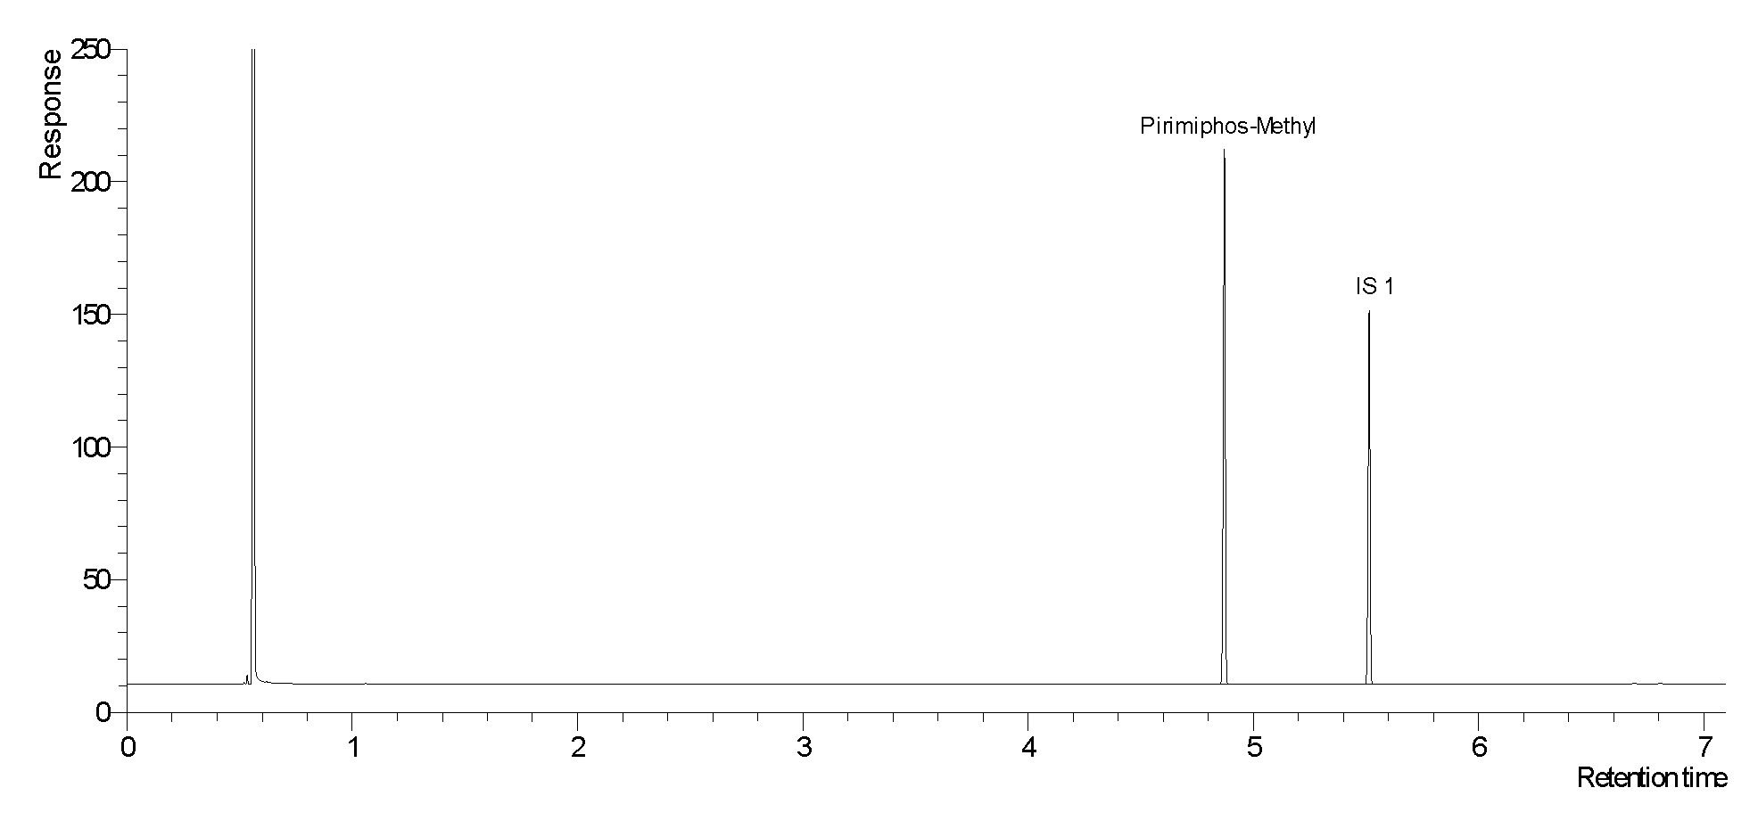

**Fig ..** Typical chromatogram of pirimiphos-methyl TC

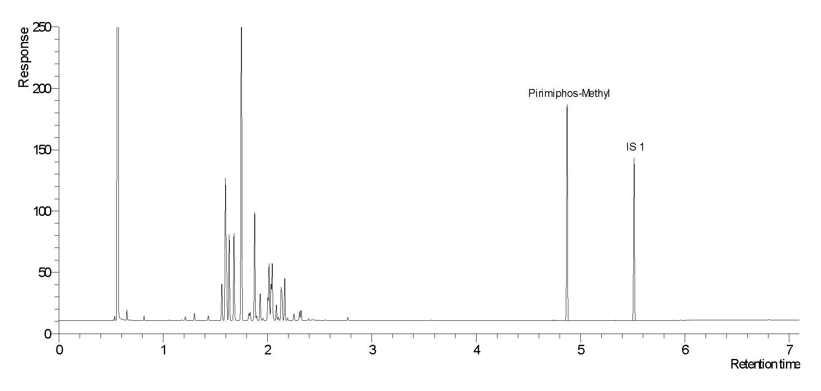

**Fig ..** Typical chromatogram of pirimiphos-methyl in EC

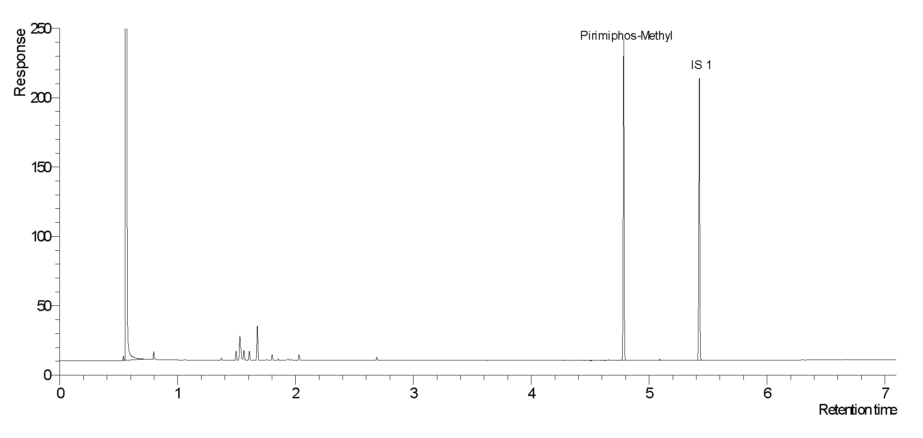

**Fig ..** Typical chromatogram of pirimiphos-methyl CS



**Fig ..**Chromatogram of pirimiphos-methyl and iso-pirimiphos-methyl in a CS formulation



**Fig** Chromatogram of relevant impurities DMPCT, MeOOOPS, MeOOSPO and MeOOSPS in pirimiphos-methyl CS with exclusion of the pirimiphos-methyl peak for a better visualisation of the impurities. Elution time of pirimiphos-methyl is 10.1 min



**Fig ..** Full MS spectrum of DMPCT



**Fig ..** Full MS spectrum of MeOOOPS



**Fig ..** Full MS spectrum of MeOOSPO



**Fig ..** Full MS spectrum of MeOOSPS



**Fig ..** Full MS spectrum of pirimiphos-methyl



**Fig ..**Full MS spectrum of iso-pirimiphos-methyl



**Fig ..** Full MS spectrum of 4,4-dimethoxybenzophenone

1. * CIPAC method 2012. Prepared by the Swiss committee. Based on a method supplied by Syngenta   
   Crop Protection AG, Switzerland.
2. * CIPAC method 2012. Prepared by the Swiss committee. Based on a method supplied by Syngenta Crop Protection AG, Switzerland