Prallethrin

743

743/LV/M/-

Method Extension for Prallethrin UL

Studies for Method Extension of existing CIPAC method for Prallethrin UL.

By
Kevin King
Clarke Mosquito Control
Analytical Laboratory
675 Sidwell Ct, St. Charles IL, 60174
- Introduction
The CIPAC 743/LV/M/- total prallethrin content method was extended to the UL formulation type, that contains prallethrin, with a few modifications. This report was prepared to demonstrate the validity of the extension of the CIPAC 743/LV/M/- for total prallethrin in UL formulations.

- Prallethrin Formulation Extension method of CIPAC 743/LV/M/-

Outline of CIPAC Method: Total Prallethrin is determined by capillary gas chromatography using flame ionization detection and triphenyl phosphate as internal standard.

Reagents
Acetone
Prallethrin working standard technical product of certified purity. Store refrigerated.
Triphenyl Phosphate internal standard. Must not show a peak with the same retention time as prallethrin.
Internal standard solution. Dissolve triphenyl phosphate (2.0 g) in acetone (100mL). Ensure that a sufficient quantity of this solution is prepared for all samples and calibration standards to be analysed.
Calibration Solution. Prepare calibration solutions in duplicate. Weigh (to the nearest 0.1mg) 90 to 100 mg (s mg) of prallethrin working standard into a volumetric flask (100mL). Add by pipette internal standard solution (5.0 mL) and dissolve. Make up to volume with acetone and mix well (solutions C_{A} and C_{B}).

Apparatus
Gas chromatograph equipped with a split/splitless injection and a flame ionization detector.
Capillary column fused silica, 30 m x 0.25 (i.d.) mm, film thickness: 0.25 µm, coated with crosslinked 14% cyanopropylphenyl 86% dimethyl polysiloxane (DB-1701 or equivalent)
Electronic integrator or data system

Procedure
  - Chromatographic Conditions (typical)
Parameter | Specification
Column | fused silica, 30 m x 0.25 (i.d.) mm, film thickness: 0.25 µm, coated with crosslinked 14% cyanopropylphenyl 86% dimethyl polysiloxane (DB-1701 or equivalent)
Injector | Split injection
Split Flow | Approximately 100 mL/min
Injection Volume | 1 µL
Detector | Flame ionization
Column Oven | 245 ºC
Injection Port | 270 ºC
Detector | 270 ºC
Carrier Gas | Helium, 35cm/s
Retention Times | Prallethrin: about 4.7 min  Triphenyl Phosphate: about 10.2 min

  - Linearity check
Check the linearity of the detector response by injecting 1 µL of solutions with prallethrin concentrations 0.5, 1, and 2 times that of the calibration solution before conducting analysis. The solutions prepared had theoretical concentrations (mg/mL): 0.487, 0.973, and 1.945. When plotted vs their response time the R² value was ≥0.99.
As one can see from the graph, this shows the linearity of the system is acceptable in reference to the prallethrin response vs concentration from 0.5x to 2x of calibration solution concentration.
  - System equilibration
Prepare two calibration solutions. Inject 1 µL portions of the first one until the response factors obtained for two consecutive injections differ by less than 1.0%. Then inject a 1 µL portion of the second solution. The response factor for this solution should not deviate by more than 1.0% from that for the first calibration solution, otherwise prepare new calibration solutions.
  - Preparation of sample solution
Prepare sample solutions in duplicate for each sample. Weigh (to the nearest 0.1 mg) 90 to 110 mg (w mg) of prallethrin technical into a volumetric flask (100 mL). Add by pipette internal standard solution (5.0 mL) and dissolve. Make up to volume with acetone and mix well. (Solutions S_{A} and S_{B}).
  - Determination
Inject in duplicate 1 µL portions of each sample solution bracketing them by injections of the calibration solutions as follows: calibration solution C_{A}, sample solution S_{A}, sample solution S_{B}, calibration solution C_{B}, sample solution S_{B}, sample solution S_{B}, calibration solution C_{A}, and so on. Measure the relevant peak areas.

  - Calculation
Calculate the mean value of each pair of response factors bracketing the two injections of a sample and use this value for calculating the prallethrin contents of the bracketed sample injections.
f_{i} = I_{r} * s * P / H_{s}
Prallethrin content (g/kg) = f * H_{w} / (I_{q} * w)
Where:
f_{i} = individual response factor
f = mean response factor
H_{s} = peak area of prallethrin in the calibration solution
H_{w} = peak area of prallethrin in the sample solution
I_{r} = peak area of the internal standard in the calibration solution
I_{q} = peak area of the internal standard in the sample solution
s = mass of prallethrin in the calibration solution (mg)
w = mass of sample taken (mg)
P = purity of prallethrin standard (g/kg)

- Method Assessment
According to the CIPAC method extension guideline, the method extension of the CIPAC 743/LV/M/- for total prallethrin in UL formulations was investigated.
One UL formulation, CMP123-004, was subjected to this assessment. The nominal content of total prallethrin in the UL formulation tested is 7.5 g/kg
  - Check the availability of a CIPAC method for the formulation concerned (Step 1)
The formulation of interest is a combination active ingredient formulation. There is no existing CIPAC method available for the UL formulation type containing prallethrin. The formulation of interest, CMP123-004, contains prallethrin. The method extension of CIPAC 743/LV/M/- was investigated.
  - Check whether the concentration of the analyte is inside or outside the acceptability range covered by the samples of the original trial (Step 2)
CIPAC 743/LV/M/- was originally evaluated for concentrations of 10.5g/kg (0.9 to 1.1 mg/ml, in final sample solutions) The prallethrin content in the formulation of interest is 7.5 g/kg. This is within the acceptability range of the existing CIPAC method. In the preparation of the sample, the prallethrin concentration in the sample solution was set to 1 mg/ml as described in the sample preparation section of the existing CIPAC method. This is the identical concentration of prallethrin that is present in the calibration solutions, thus the analysis of the sample solution per the CIPAC method falls within the acceptable linearity range.
  - Modification of method has to be changed in order to be specific (Step 4)
In order to apply the CIPAC 743/LV/M/- methodology to the formulation of interest, CMP123-004, the following modifications were applied:
    - Detector temperature changed from 270 ºC to 320 ºC
    - Column oven temperature changed from 245 ºC isothermal, to 50 ºC for 0.5 min then 40 ºC/min up to 240 ºC for 15min. This was necessary in order to ensure complete separation of formulation components from the prallethrin peak.
    - Injection port temperature changed from 270 ºC to 275 ºC
    - Carrier gas flow changed from 35 cm/s to 41.541 cm/s (flow rate 2ml/min)
This resulted in the following retention times for peaks of Interest
Peak Identity | Ret time (minutes), modified CIPAC method | Ret time (minutes), original CIPAC method
Prallethrin | 9.07 | 4.7
Triphenyl phosphate | 15.60 | 10.2

These are considered to be minor modifications.
Furthermore, due to a combination of large sample weight required, and other ingredients of the formulation, separation of the internal standard in the sample solution was not achievable. The calculations to determine the amount of prallethrin content will be changed to external standard using the following equation:
f = s * P / H_{s}
Prallethrin content (g/kg) = H_{w} * f / w
Where:
f = mean response factor
H_{s} = peak area of prallethrin in the calibration solution
H_{w} = peak area of prallethrin in the sample solution
s = mass of prallethrin in the calibration solution (mg)
w = mass of sample taken (mg)
P = purity of prallethrin standard (g/kg)
  - Validation Study (Step 5)
Linearity, specificity, and precision tests were conducted.
    - Linearity
Prallethrin concentrations of 0.5x, 1x, and 2x the prallethrin concentration in the calibration standard were injected. The correlation coefficient (R²) for this curve was ≥ 0.99 thus the instrument is able to prove linearity of prallethrin analysis.
    - Specificity
The sample solutions and a blank solution were prepared identically. A comparative (refer to chromatogram figures) evaluation of the sample solution, blank solution, and the standard solution show that there is no interference with the analysis of prallethrin. However, in the sample formulation, the resolution and identification of the triphenyl phosphate peak is not possible to due to a large interfering peak. Because the interfering peak is present in only the sample and not the blank, it can be deduced that one of the other active ingredients is eluting with a retention time similar to that of triphenyl phosphate.

    - Precision (repeatability, r)
The UL sample was prepared in 5 replicates (5 separate sub samples) and analyzed according to the specified chromatographic conditions with the exception of the modifications listed above in 3(C). Per the Horwitz equation, the acceptable %RSD for a sample with a nominal 0.75% concentration is as follows:
%RSD = 2 * C^{-0.15}
C = concentration of analyte expressed as a decimal
For a 0.75% concentration, this equates to (2 * .0075^{-.15}) which is 4.17%. As shown in the table below, the repeatability of this method was satisfactory with a %RSD of 1.20%
Replicate | Prallethrin Content (g/kg)
1 | 7.03
2 | 6.92
3 | 6.94
4 | 7.05
5 | 7.16
Avg | 7.01
%RSD | 1.20
Conclusion
In order to apply the CIPAC 743/LV/M/- to UL formulations containing prallethrin, the method required some minor chromatographic conditions. In addition, the presence of other formulation components prohibited the use of the TPP internal standard, and so the calculation of the prallethrin content is based upon the prallethrin standard alone (external standard calculation).
The data shown demonstrates that the method is linear, specific, and has acceptable precision (repeatability, r). Therefore, the modified method is considered appropriate for the determination of total prallethrin in a UL formulation and the extension of CIPAC 743/LV/M/- to UL formulations is proposed by Clarke.
Figure 1. Diluent Injection
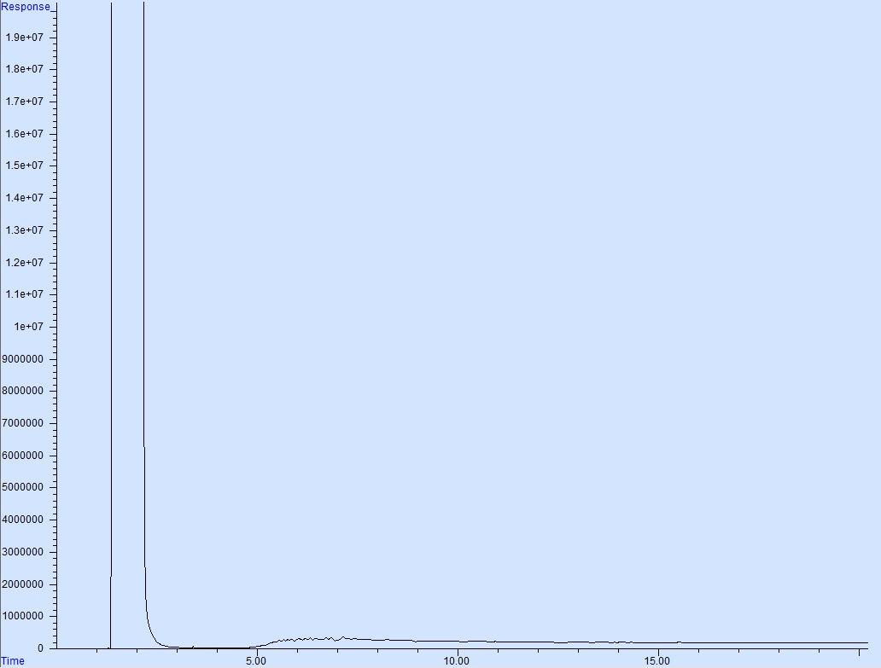

Figure 2. Calibration Solution Injection
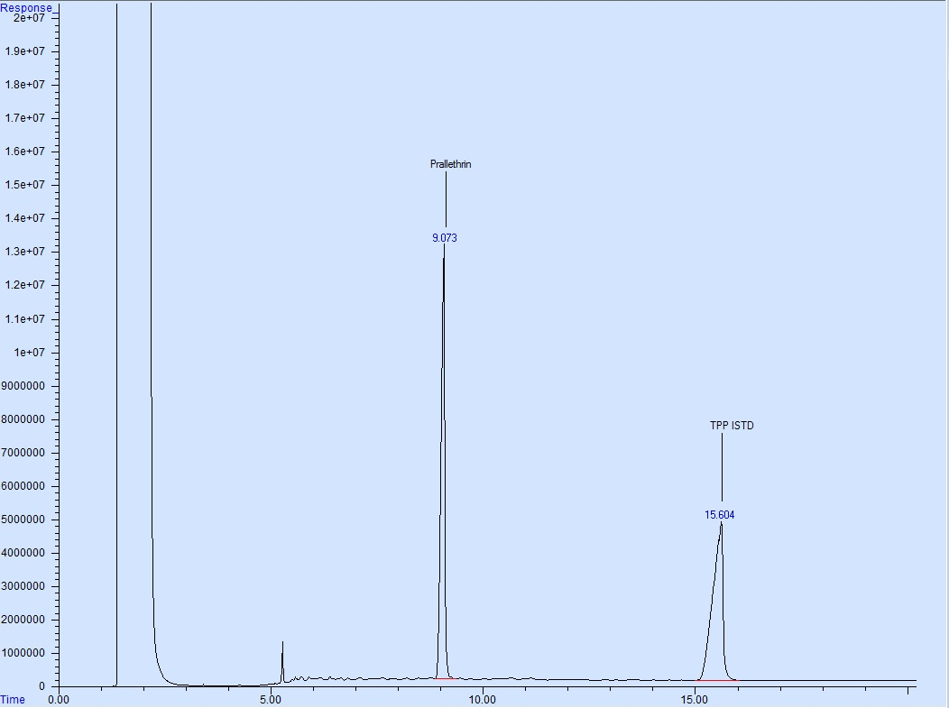

Figure 3. Blank Injection
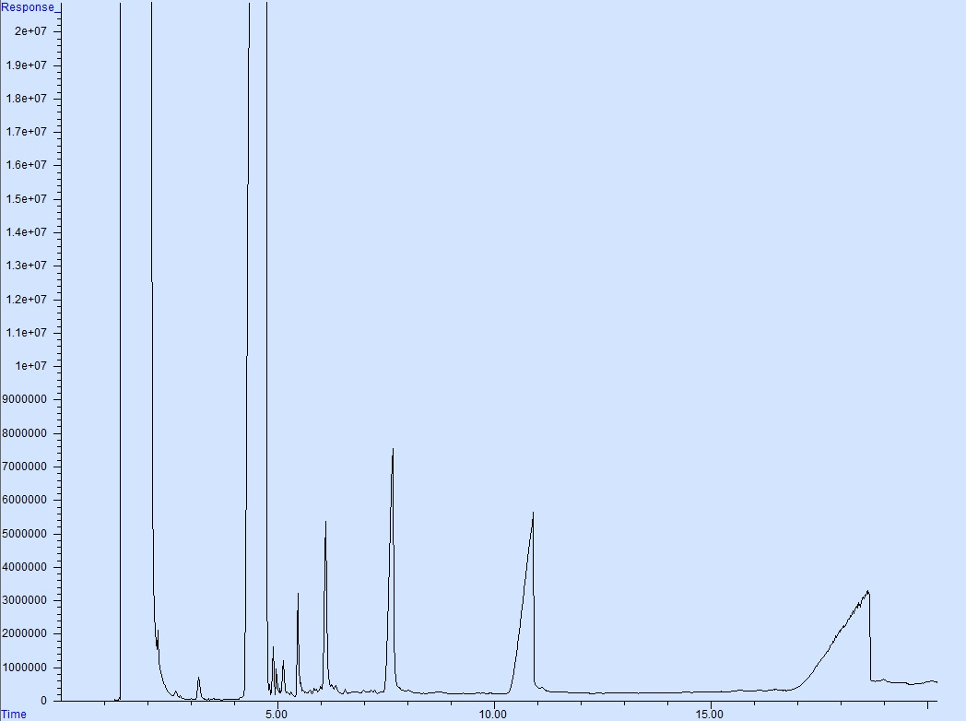

Figure 4. Sample Injection
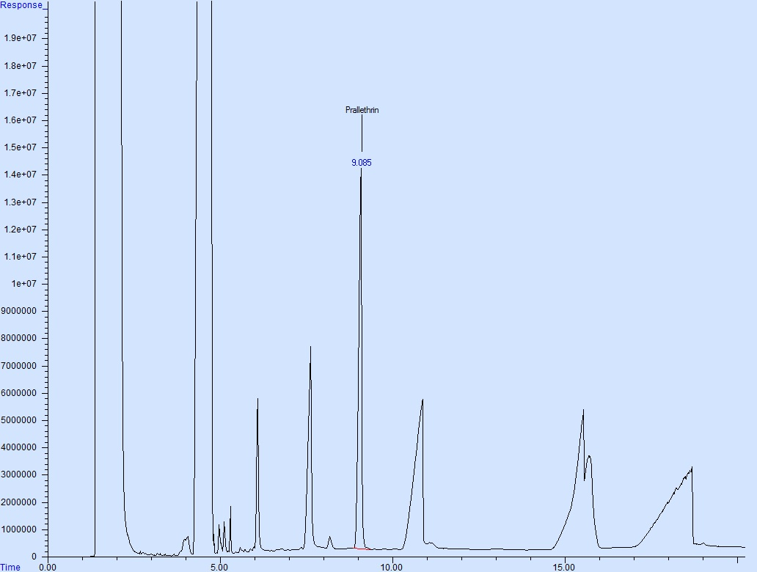

Figure 5. Blank formulation with other actives except Prallethrin
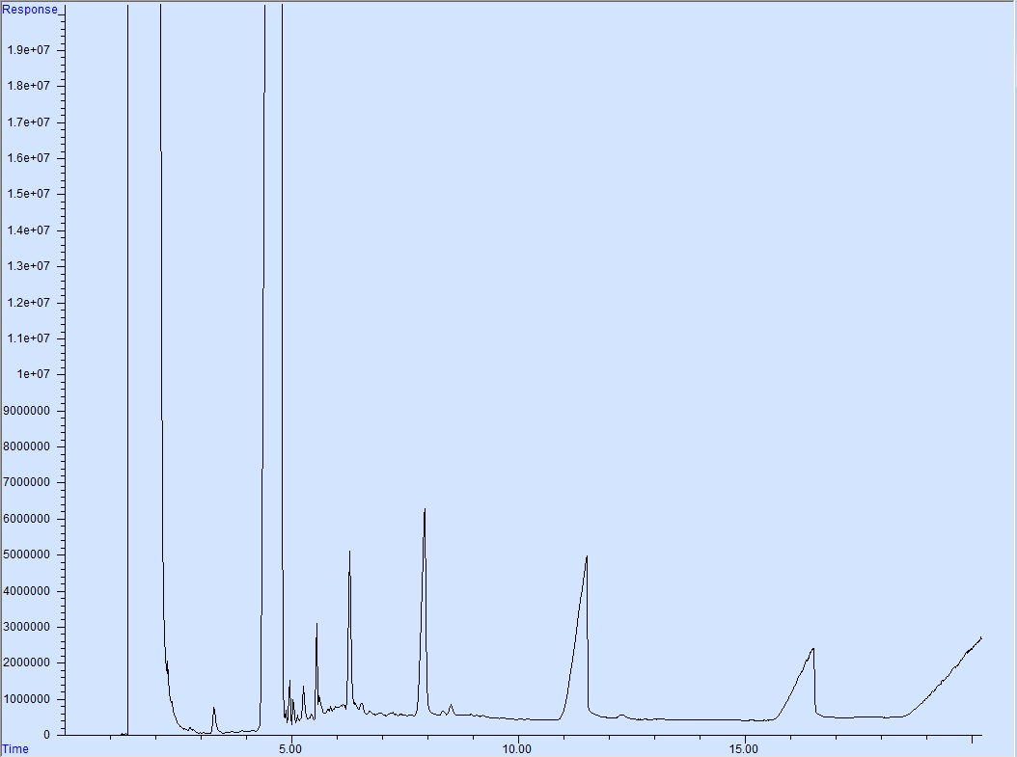

Figure 6. Calibration solution overlayed with the Blank formulation with other actives except Prallethrin
